* Context provides a way to pass data through the component tree without having to pass props down manually at every level.

Example, here prop drilling happening cause theme prop is being passed through many levels.

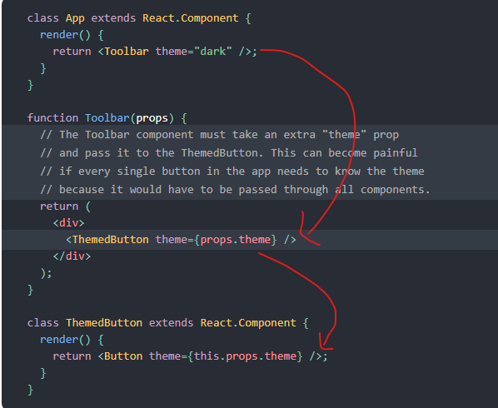

Now, using context we can avoid this.

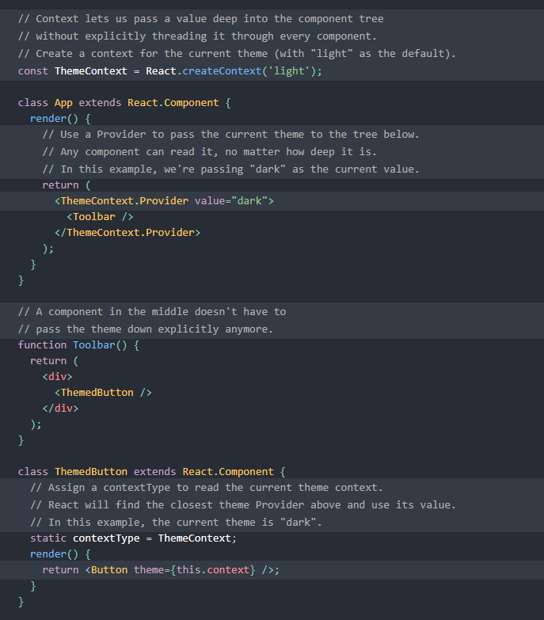

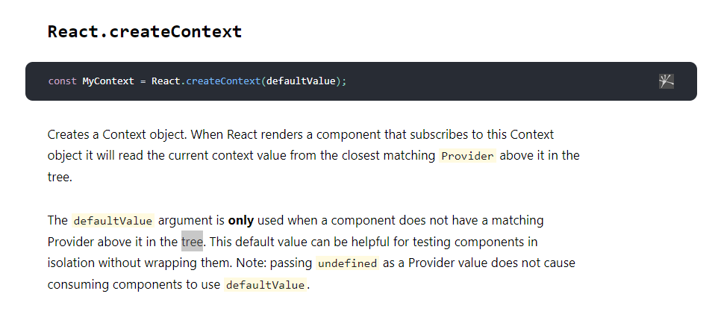

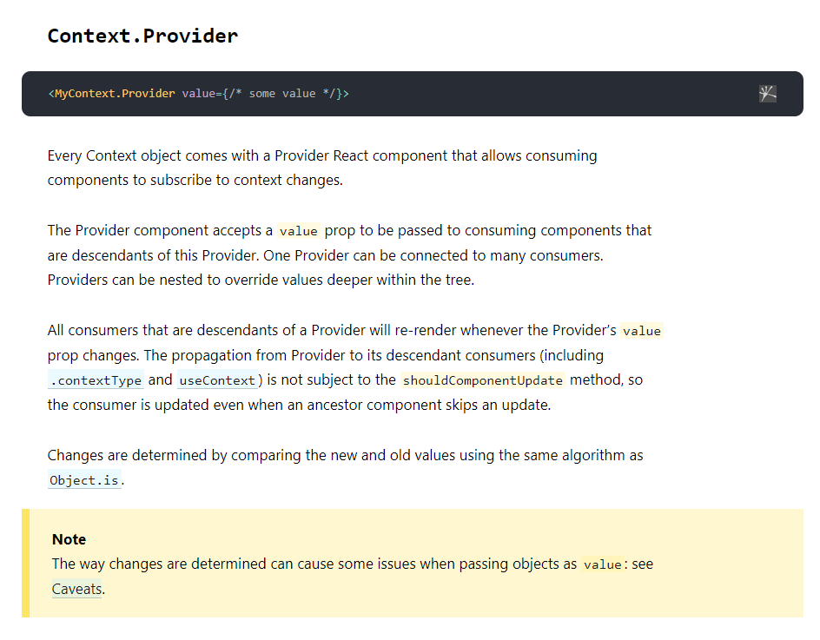

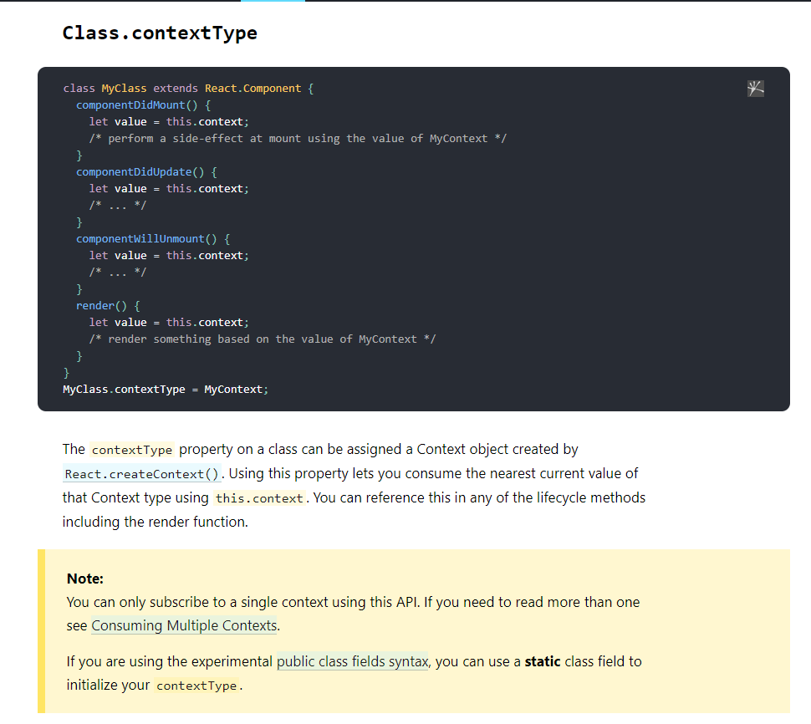

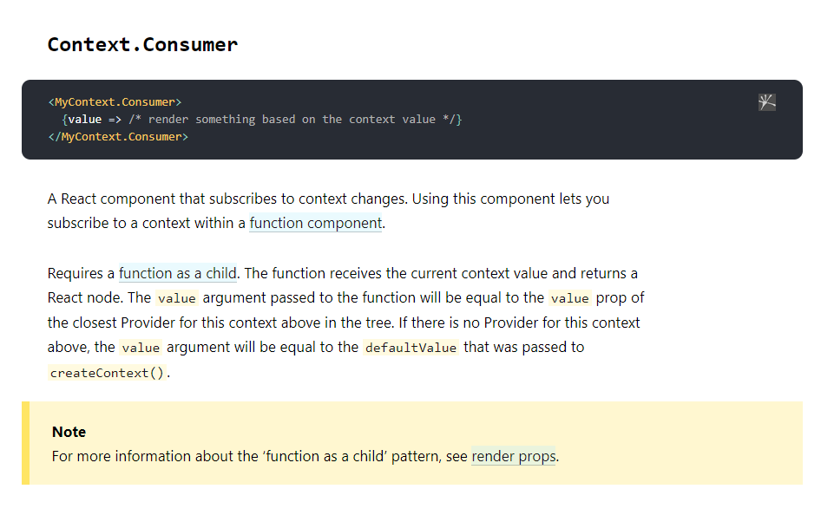

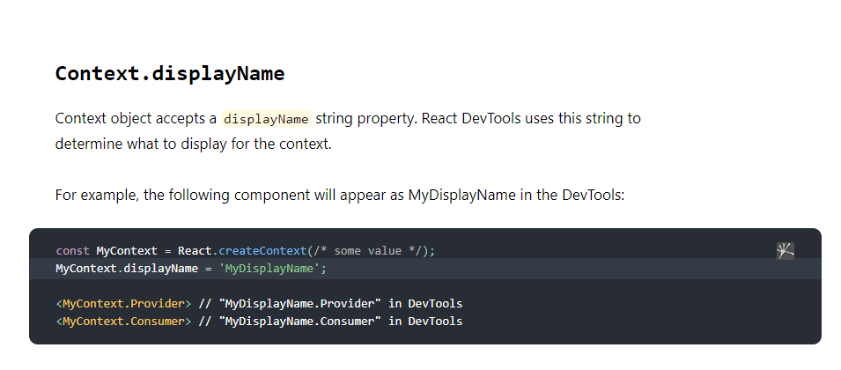

In basic form it’s a 3-step process, first we create a context, then we provide it and then we consume it. In the provider, we pass the values of the context, and in consumer we consume it with a function that receives that context as argument.

**Note**: If we want to consume the context outside the render method, we need to set the static property of that class (in this case actually functional component is much easier, it doesn’t need that many hassle)

